[](https://www.ok.ru/dk?cmd=PopLayerPhoto&st.layer.cmd=PopLayerPhotoOuter&st.layer.type=GROUP&st.layer.revNav=off&st.layer.limitedUi=false&st.layer.closeLayers=off&st.layer.sphotoIds=878689913441;878689913185;878689912929;878689912673;878689912417;878689912161;878689911905&st.layer.showNav=on&st.layer.photoAlbumId=53274829389921&st.layer.epm=off&st.layer.photoId=878689913441&st.layer.opl=off&st.layer.navStartPhotoId=878689913441&st.layer.sbd=off&st.cmd=bookmarks&st.typeId=7&st._aid=GroupTopicLayer_openPhotoLayer)

[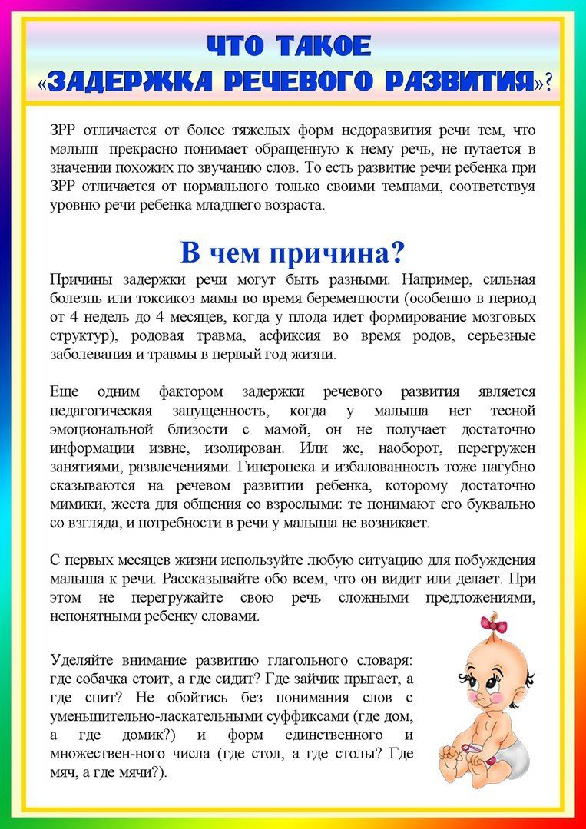](https://www.ok.ru/dk?cmd=PopLayerPhoto&st.layer.cmd=PopLayerPhotoOuter&st.layer.type=GROUP&st.layer.revNav=off&st.layer.limitedUi=false&st.layer.closeLayers=off&st.layer.sphotoIds=878689913441;878689913185;878689912929;878689912673;878689912417;878689912161;878689911905&st.layer.showNav=on&st.layer.photoAlbumId=53274829389921&st.layer.epm=off&st.layer.photoId=878689913185&st.layer.opl=off&st.layer.navStartPhotoId=878689913185&st.layer.sbd=off&st.cmd=bookmarks&st.typeId=7&st._aid=GroupTopicLayer_openPhotoLayer)

[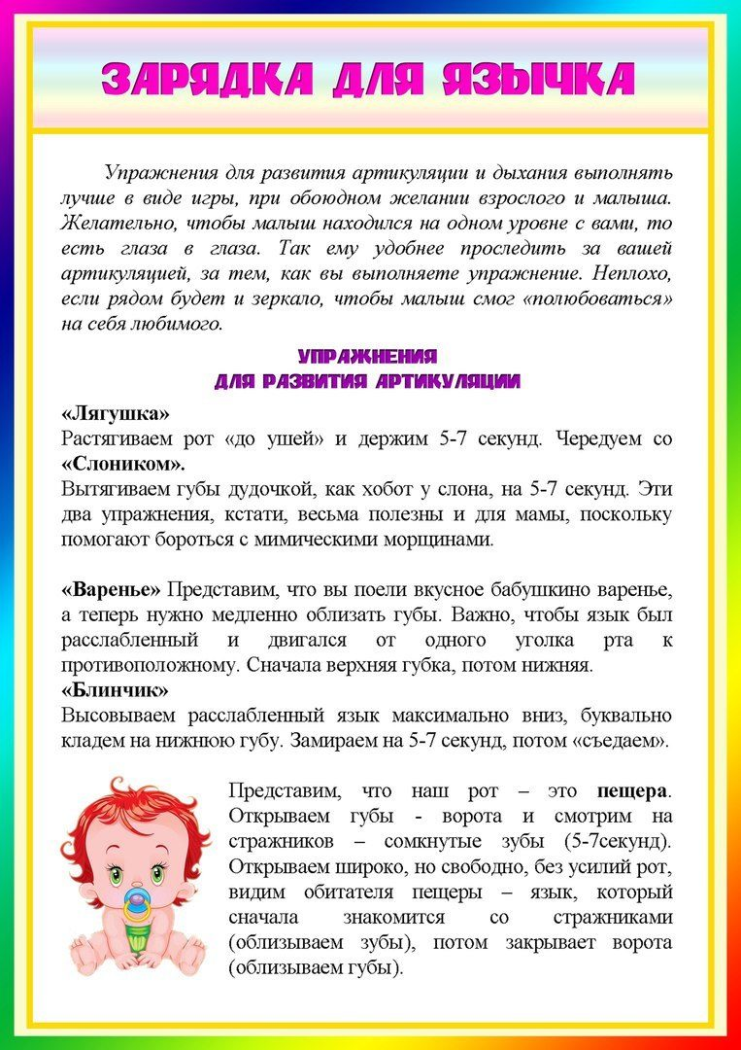](https://www.ok.ru/dk?cmd=PopLayerPhoto&st.layer.cmd=PopLayerPhotoOuter&st.layer.type=GROUP&st.layer.revNav=off&st.layer.limitedUi=false&st.layer.closeLayers=off&st.layer.sphotoIds=878689913441;878689913185;878689912929;878689912673;878689912417;878689912161;878689911905&st.layer.showNav=on&st.layer.photoAlbumId=53274829389921&st.layer.epm=off&st.layer.photoId=878689912929&st.layer.opl=off&st.layer.navStartPhotoId=878689912929&st.layer.sbd=off&st.cmd=bookmarks&st.typeId=7&st._aid=GroupTopicLayer_openPhotoLayer)

[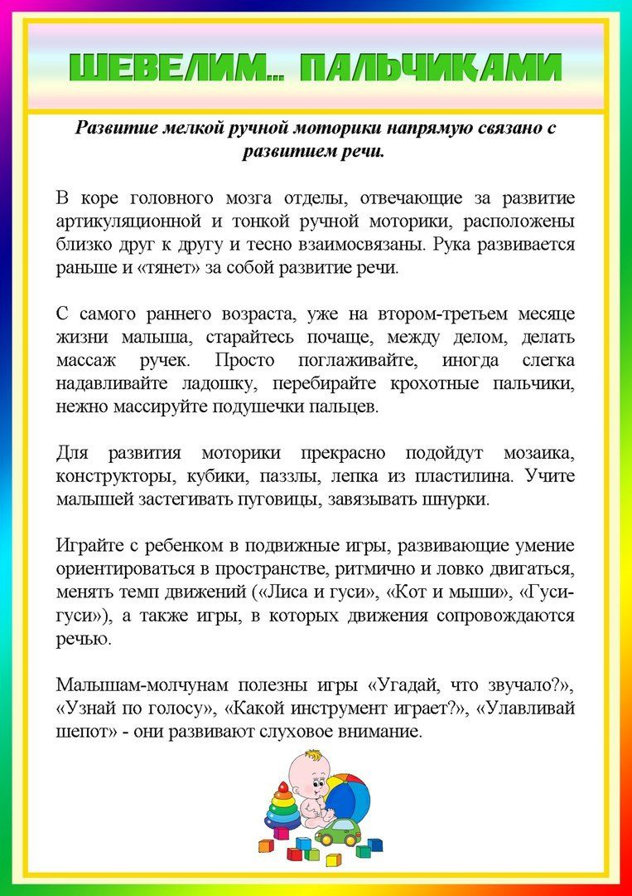](https://www.ok.ru/dk?cmd=PopLayerPhoto&st.layer.cmd=PopLayerPhotoOuter&st.layer.type=GROUP&st.layer.revNav=off&st.layer.limitedUi=false&st.layer.closeLayers=off&st.layer.sphotoIds=878689913441;878689913185;878689912929;878689912673;878689912417;878689912161;878689911905&st.layer.showNav=on&st.layer.photoAlbumId=53274829389921&st.layer.epm=off&st.layer.photoId=878689912673&st.layer.opl=off&st.layer.navStartPhotoId=878689912673&st.layer.sbd=off&st.cmd=bookmarks&st.typeId=7&st._aid=GroupTopicLayer_openPhotoLayer)

[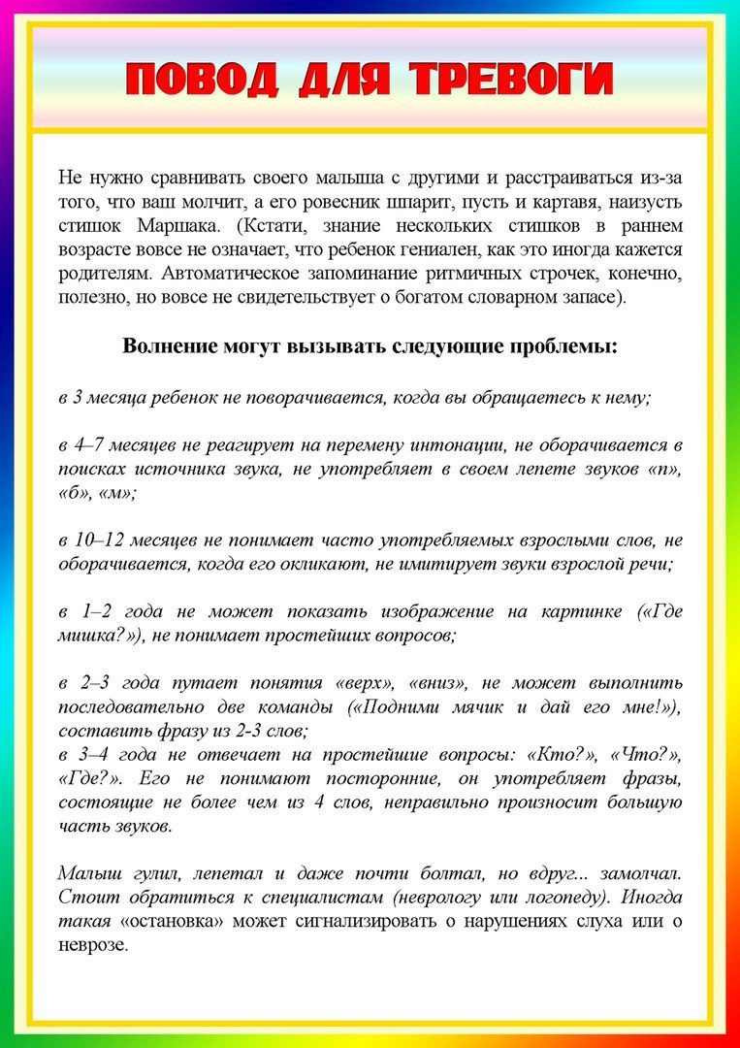](https://www.ok.ru/dk?cmd=PopLayerPhoto&st.layer.cmd=PopLayerPhotoOuter&st.layer.type=GROUP&st.layer.revNav=off&st.layer.limitedUi=false&st.layer.closeLayers=off&st.layer.sphotoIds=878689913441;878689913185;878689912929;878689912673;878689912417;878689912161;878689911905&st.layer.showNav=on&st.layer.photoAlbumId=53274829389921&st.layer.epm=off&st.layer.photoId=878689912417&st.layer.opl=off&st.layer.navStartPhotoId=878689912417&st.layer.sbd=off&st.cmd=bookmarks&st.typeId=7&st._aid=GroupTopicLayer_openPhotoLayer)

[](https://www.ok.ru/dk?cmd=PopLayerPhoto&st.layer.cmd=PopLayerPhotoOuter&st.layer.type=GROUP&st.layer.revNav=off&st.layer.limitedUi=false&st.layer.closeLayers=off&st.layer.sphotoIds=878689913441;878689913185;878689912929;878689912673;878689912417;878689912161;878689911905&st.layer.showNav=on&st.layer.photoAlbumId=53274829389921&st.layer.epm=off&st.layer.photoId=878689912161&st.layer.opl=off&st.layer.navStartPhotoId=878689912161&st.layer.sbd=off&st.cmd=bookmarks&st.typeId=7&st._aid=GroupTopicLayer_openPhotoLayer)

[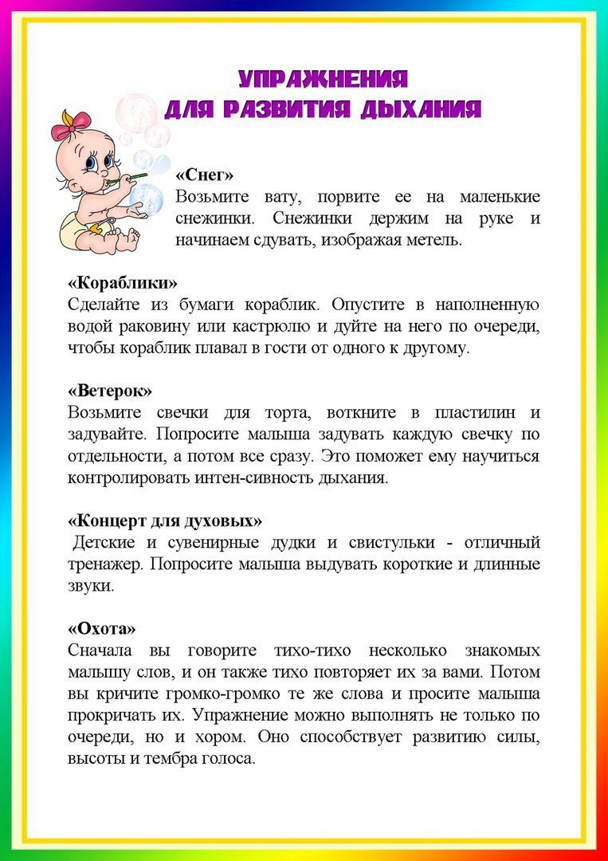](https://www.ok.ru/dk?cmd=PopLayerPhoto&st.layer.cmd=PopLayerPhotoOuter&st.layer.type=GROUP&st.layer.revNav=off&st.layer.limitedUi=false&st.layer.closeLayers=off&st.layer.sphotoIds=878689913441;878689913185;878689912929;878689912673;878689912417;878689912161;878689911905&st.layer.showNav=on&st.layer.photoAlbumId=53274829389921&st.layer.epm=off&st.layer.photoId=878689911905&st.layer.opl=off&st.layer.navStartPhotoId=878689911905&st.layer.sbd=off&st.cmd=bookmarks&st.typeId=7&st._aid=GroupTopicLayer_openPhotoLayer)