[](https://www.ok.ru/dk?cmd=PopLayerPhoto&st.layer.cmd=PopLayerPhotoOuter&st.layer.type=GROUP&st.layer.revNav=off&st.layer.limitedUi=false&st.layer.closeLayers=off&st.layer.sphotoIds=871249346740;871249346996;871249347252;871249347508;871249347764;871249346228;871249346484&st.layer.showNav=on&st.layer.photoAlbumId=53539413622964&st.layer.epm=off&st.layer.photoId=871249346740&st.layer.opl=off&st.layer.navStartPhotoId=871249346740&st.layer.sbd=off&st.cmd=altGroupMain&st.groupId=53539382296756&st.referenceName=logope&st._aid=GroupTopicLayer_openPhotoLayer)

**Подготовили воспитатели:**

**Луцевич И.Н.**

**Сотникова Е. А**

[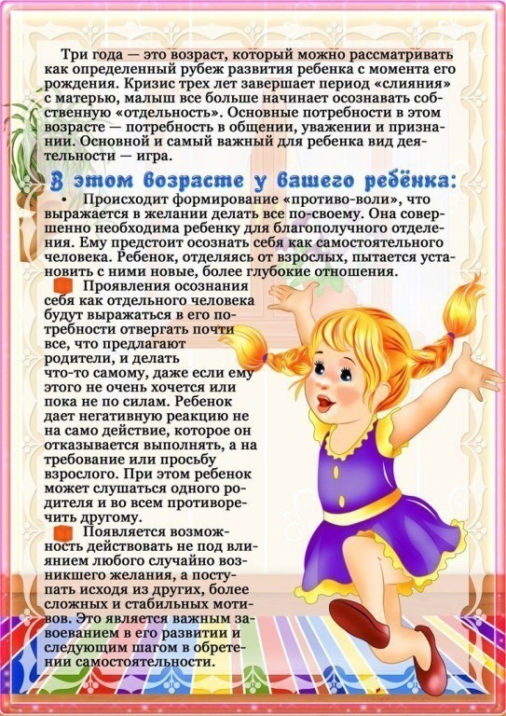](https://www.ok.ru/dk?cmd=PopLayerPhoto&st.layer.cmd=PopLayerPhotoOuter&st.layer.type=GROUP&st.layer.revNav=off&st.layer.limitedUi=false&st.layer.closeLayers=off&st.layer.sphotoIds=871249346740;871249346996;871249347252;871249347508;871249347764;871249346228;871249346484&st.layer.showNav=on&st.layer.photoAlbumId=53539413622964&st.layer.epm=off&st.layer.photoId=871249346996&st.layer.opl=off&st.layer.navStartPhotoId=871249346996&st.layer.sbd=off&st.cmd=altGroupMain&st.groupId=53539382296756&st.referenceName=logope&st._aid=GroupTopicLayer_openPhotoLayer)

[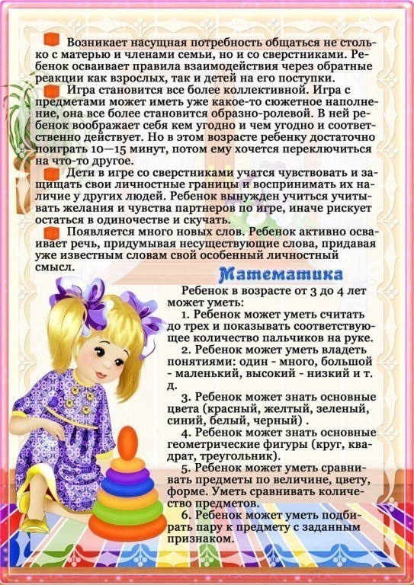](https://www.ok.ru/dk?cmd=PopLayerPhoto&st.layer.cmd=PopLayerPhotoOuter&st.layer.type=GROUP&st.layer.revNav=off&st.layer.limitedUi=false&st.layer.closeLayers=off&st.layer.sphotoIds=871249346740;871249346996;871249347252;871249347508;871249347764;871249346228;871249346484&st.layer.showNav=on&st.layer.photoAlbumId=53539413622964&st.layer.epm=off&st.layer.photoId=871249347252&st.layer.opl=off&st.layer.navStartPhotoId=871249347252&st.layer.sbd=off&st.cmd=altGroupMain&st.groupId=53539382296756&st.referenceName=logope&st._aid=GroupTopicLayer_openPhotoLayer)

[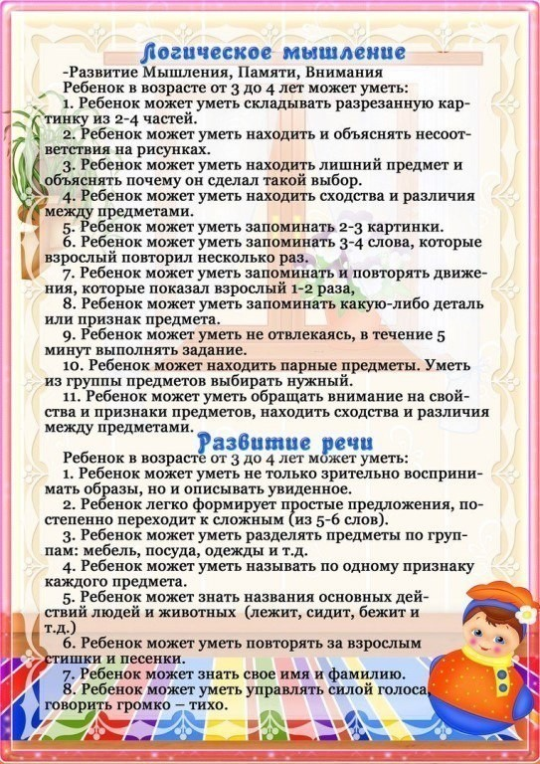](https://www.ok.ru/dk?cmd=PopLayerPhoto&st.layer.cmd=PopLayerPhotoOuter&st.layer.type=GROUP&st.layer.revNav=off&st.layer.limitedUi=false&st.layer.closeLayers=off&st.layer.sphotoIds=871249346740;871249346996;871249347252;871249347508;871249347764;871249346228;871249346484&st.layer.showNav=on&st.layer.photoAlbumId=53539413622964&st.layer.epm=off&st.layer.photoId=871249347508&st.layer.opl=off&st.layer.navStartPhotoId=871249347508&st.layer.sbd=off&st.cmd=altGroupMain&st.groupId=53539382296756&st.referenceName=logope&st._aid=GroupTopicLayer_openPhotoLayer)

[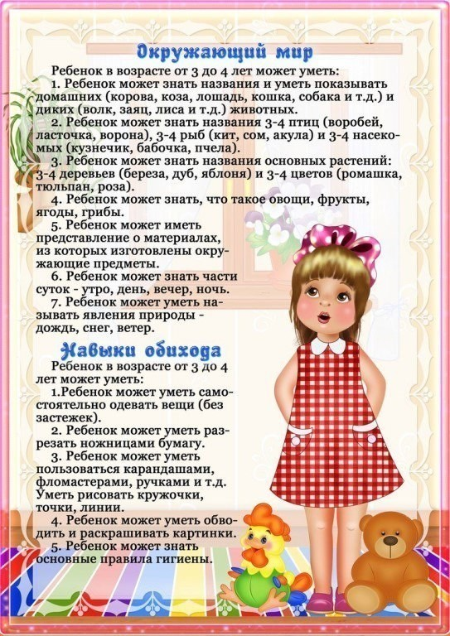](https://www.ok.ru/dk?cmd=PopLayerPhoto&st.layer.cmd=PopLayerPhotoOuter&st.layer.type=GROUP&st.layer.revNav=off&st.layer.limitedUi=false&st.layer.closeLayers=off&st.layer.sphotoIds=871249346740;871249346996;871249347252;871249347508;871249347764;871249346228;871249346484&st.layer.showNav=on&st.layer.photoAlbumId=53539413622964&st.layer.epm=off&st.layer.photoId=871249347764&st.layer.opl=off&st.layer.navStartPhotoId=871249347764&st.layer.sbd=off&st.cmd=altGroupMain&st.groupId=53539382296756&st.referenceName=logope&st._aid=GroupTopicLayer_openPhotoLayer)

[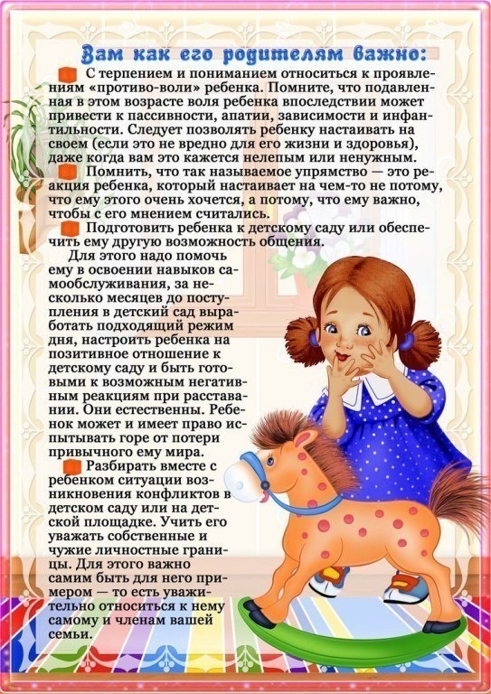](https://www.ok.ru/dk?cmd=PopLayerPhoto&st.layer.cmd=PopLayerPhotoOuter&st.layer.type=GROUP&st.layer.revNav=off&st.layer.limitedUi=false&st.layer.closeLayers=off&st.layer.sphotoIds=871249346740;871249346996;871249347252;871249347508;871249347764;871249346228;871249346484&st.layer.showNav=on&st.layer.photoAlbumId=53539413622964&st.layer.epm=off&st.layer.photoId=871249346228&st.layer.opl=off&st.layer.navStartPhotoId=871249346228&st.layer.sbd=off&st.cmd=altGroupMain&st.groupId=53539382296756&st.referenceName=logope&st._aid=GroupTopicLayer_openPhotoLayer)

[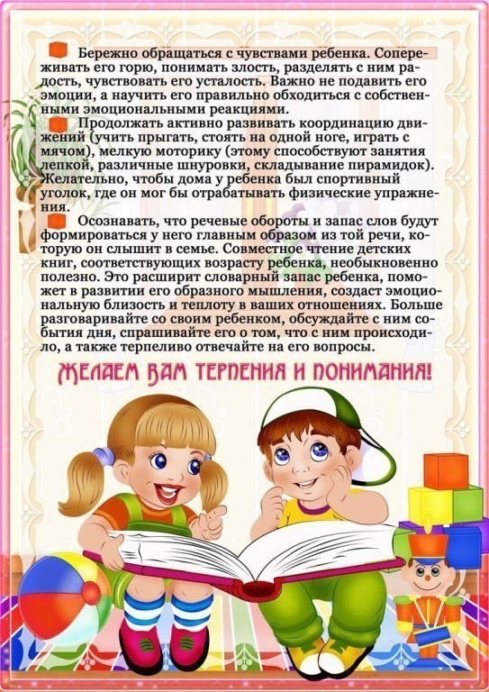](https://www.ok.ru/dk?cmd=PopLayerPhoto&st.layer.cmd=PopLayerPhotoOuter&st.layer.type=GROUP&st.layer.revNav=off&st.layer.limitedUi=false&st.layer.closeLayers=off&st.layer.sphotoIds=871249346740;871249346996;871249347252;871249347508;871249347764;871249346228;871249346484&st.layer.showNav=on&st.layer.photoAlbumId=53539413622964&st.layer.epm=off&st.layer.photoId=871249346484&st.layer.opl=off&st.layer.navStartPhotoId=871249346484&st.layer.sbd=off&st.cmd=altGroupMain&st.groupId=53539382296756&st.referenceName=logope&st._aid=GroupTopicLayer_openPhotoLayer)