[](https://www.ok.ru/dk?cmd=PopLayerPhoto&st.layer.cmd=PopLayerPhotoOuter&st.layer.type=GROUP&st.layer.revNav=off&st.layer.limitedUi=false&st.layer.closeLayers=off&st.layer.sphotoIds=866065491267;866065491011;866065490755;866065490499&st.layer.showNav=on&st.layer.photoAlbumId=53073113251907&st.layer.epm=off&st.layer.photoId=866065491267&st.layer.opl=off&st.layer.navStartPhotoId=866065491267&st.layer.sbd=off&st.cmd=userPage&st._aid=GroupTopicLayer_openPhotoLayer)

[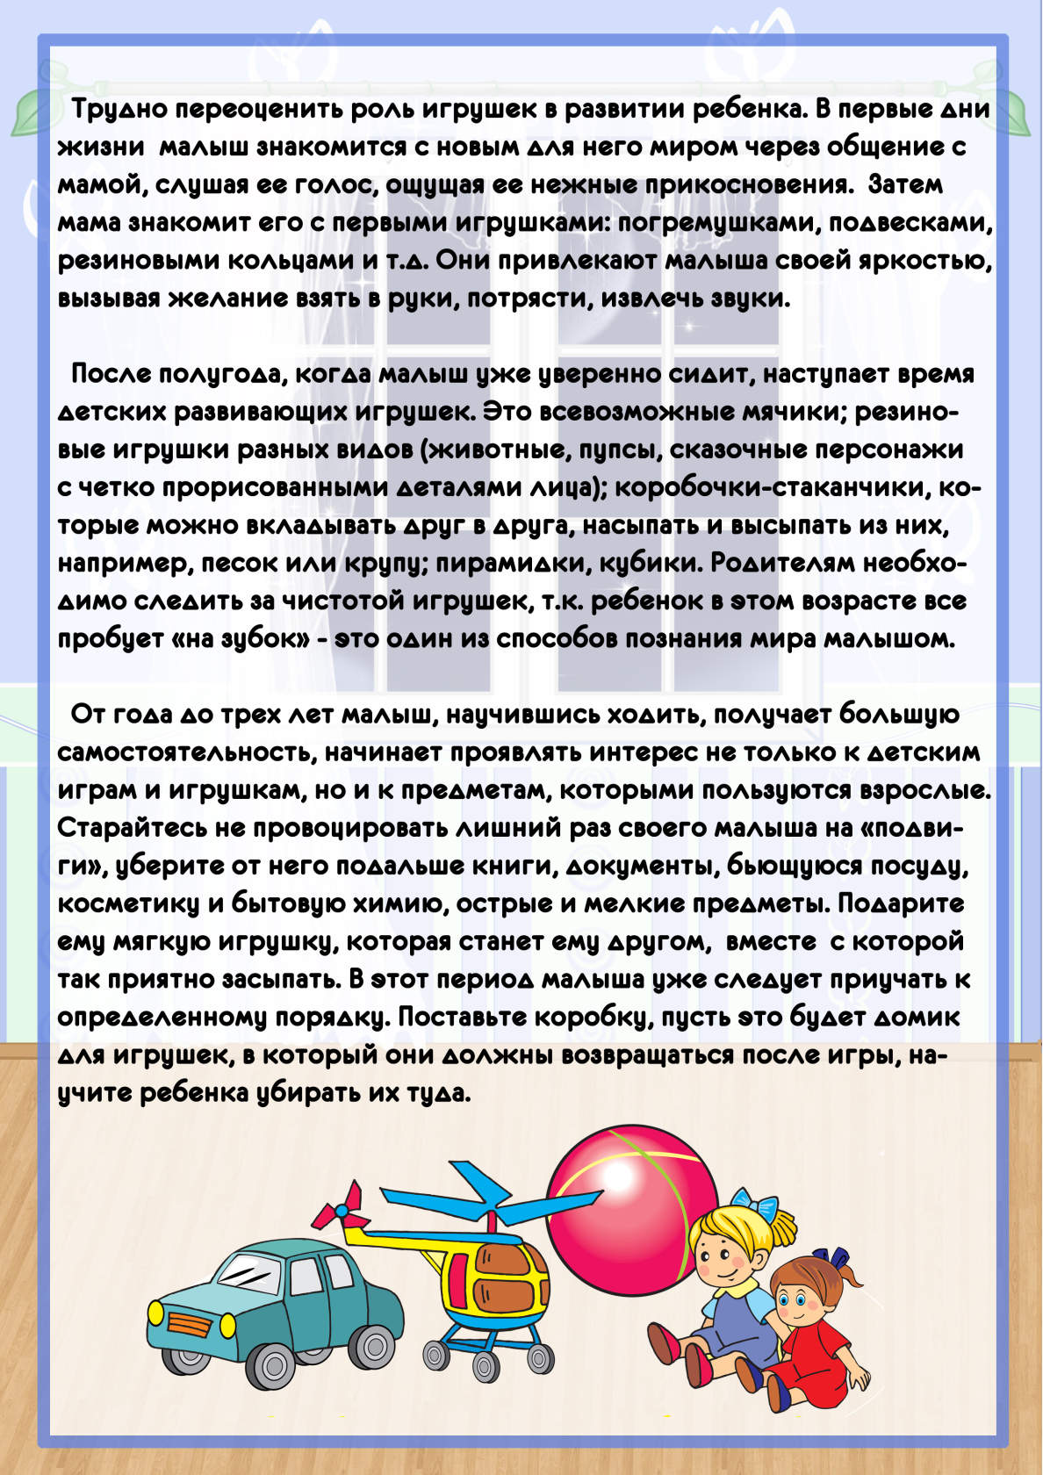](https://www.ok.ru/dk?cmd=PopLayerPhoto&st.layer.cmd=PopLayerPhotoOuter&st.layer.type=GROUP&st.layer.revNav=off&st.layer.limitedUi=false&st.layer.closeLayers=off&st.layer.sphotoIds=866065491267;866065491011;866065490755;866065490499&st.layer.showNav=on&st.layer.photoAlbumId=53073113251907&st.layer.epm=off&st.layer.photoId=866065491011&st.layer.opl=off&st.layer.navStartPhotoId=866065491011&st.layer.sbd=off&st.cmd=userPage&st._aid=GroupTopicLayer_openPhotoLayer)

[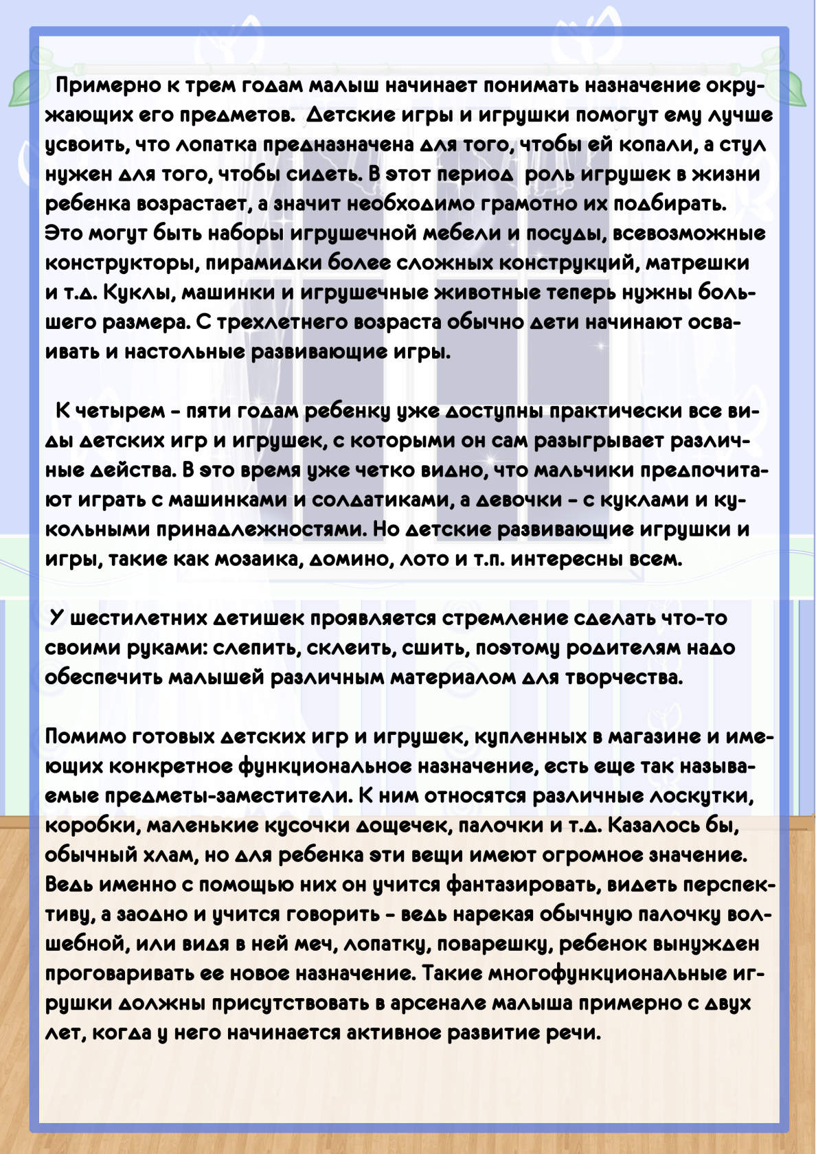](https://www.ok.ru/dk?cmd=PopLayerPhoto&st.layer.cmd=PopLayerPhotoOuter&st.layer.type=GROUP&st.layer.revNav=off&st.layer.limitedUi=false&st.layer.closeLayers=off&st.layer.sphotoIds=866065491267;866065491011;866065490755;866065490499&st.layer.showNav=on&st.layer.photoAlbumId=53073113251907&st.layer.epm=off&st.layer.photoId=866065490755&st.layer.opl=off&st.layer.navStartPhotoId=866065490755&st.layer.sbd=off&st.cmd=userPage&st._aid=GroupTopicLayer_openPhotoLayer)

[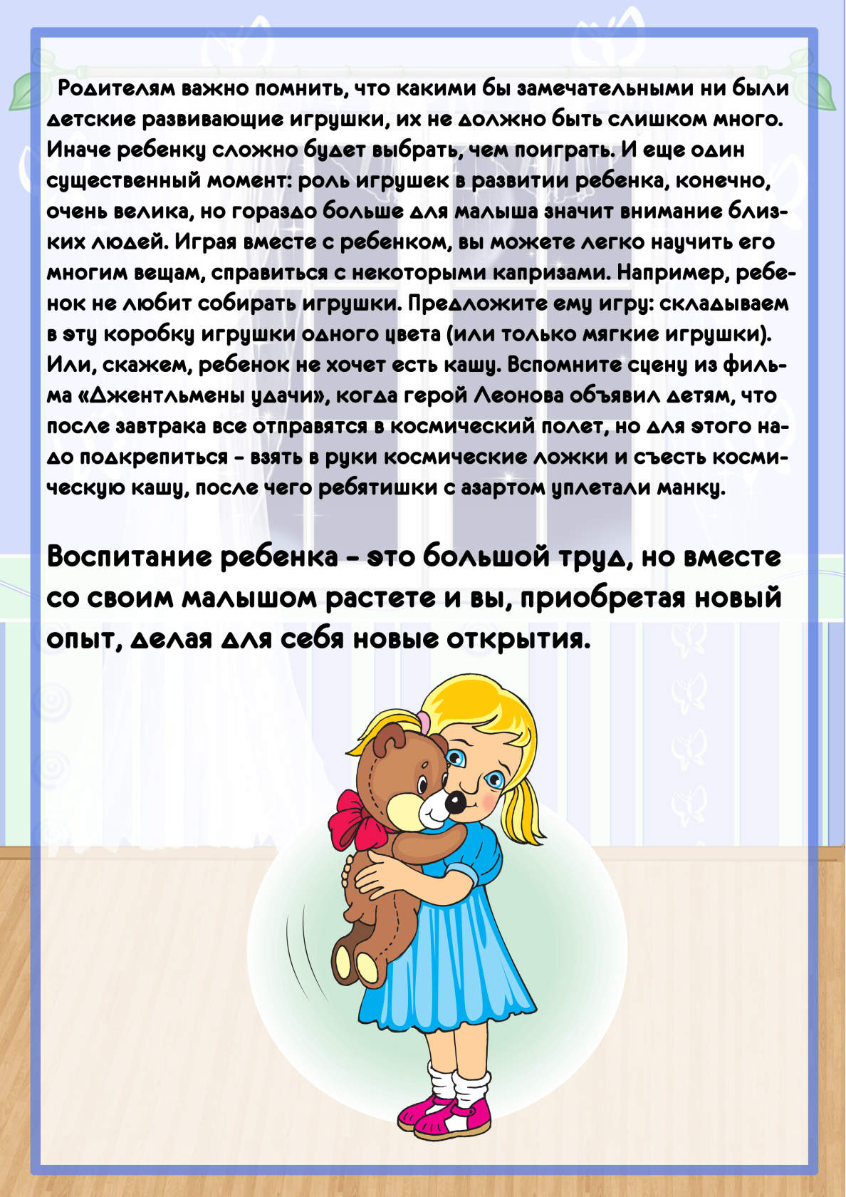](https://www.ok.ru/dk?cmd=PopLayerPhoto&st.layer.cmd=PopLayerPhotoOuter&st.layer.type=GROUP&st.layer.revNav=off&st.layer.limitedUi=false&st.layer.closeLayers=off&st.layer.sphotoIds=866065491267;866065491011;866065490755;866065490499&st.layer.showNav=on&st.layer.photoAlbumId=53073113251907&st.layer.epm=off&st.layer.photoId=866065490499&st.layer.opl=off&st.layer.navStartPhotoId=866065490499&st.layer.sbd=off&st.cmd=userPage&st._aid=GroupTopicLayer_openPhotoLayer)