[](https://ok.ru/dk?cmd=PopLayerPhoto&st.layer.cmd=PopLayerPhotoOuter&st.layer.type=GROUP&st.layer.revNav=off&st.layer.limitedUi=false&st.layer.sphotoIds=857517654339;857517654083;857517653827;857517653571;857517653315;857517653059;857517668931&st.layer.showNav=on&st.layer.photoAlbumId=52181022212163&st.layer.epm=off&st.layer.photoId=857517654339&st.layer.opl=off&st.layer.navStartPhotoId=857517654339&st.layer.sbd=off&st.cmd=userMain&st._aid=GroupTopicLayer_openPhotoLayer)

[](https://ok.ru/dk?cmd=PopLayerPhoto&st.layer.cmd=PopLayerPhotoOuter&st.layer.type=GROUP&st.layer.revNav=off&st.layer.limitedUi=false&st.layer.sphotoIds=857517654339;857517654083;857517653827;857517653571;857517653315;857517653059;857517668931&st.layer.showNav=on&st.layer.photoAlbumId=52181022212163&st.layer.epm=off&st.layer.photoId=857517654083&st.layer.opl=off&st.layer.navStartPhotoId=857517654083&st.layer.sbd=off&st.cmd=userMain&st._aid=GroupTopicLayer_openPhotoLayer)

[](https://ok.ru/dk?cmd=PopLayerPhoto&st.layer.cmd=PopLayerPhotoOuter&st.layer.type=GROUP&st.layer.revNav=off&st.layer.limitedUi=false&st.layer.sphotoIds=857517654339;857517654083;857517653827;857517653571;857517653315;857517653059;857517668931&st.layer.showNav=on&st.layer.photoAlbumId=52181022212163&st.layer.epm=off&st.layer.photoId=857517653827&st.layer.opl=off&st.layer.navStartPhotoId=857517653827&st.layer.sbd=off&st.cmd=userMain&st._aid=GroupTopicLayer_openPhotoLayer)

[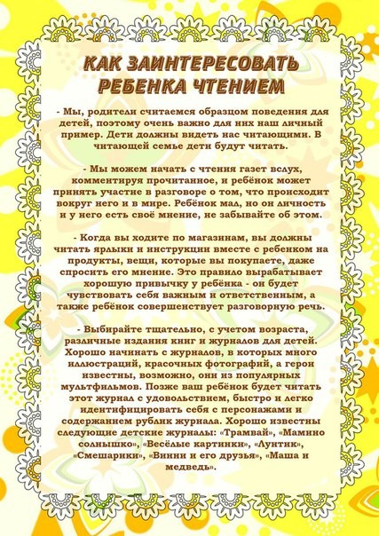](https://ok.ru/dk?cmd=PopLayerPhoto&st.layer.cmd=PopLayerPhotoOuter&st.layer.type=GROUP&st.layer.revNav=off&st.layer.limitedUi=false&st.layer.sphotoIds=857517654339;857517654083;857517653827;857517653571;857517653315;857517653059;857517668931&st.layer.showNav=on&st.layer.photoAlbumId=52181022212163&st.layer.epm=off&st.layer.photoId=857517653571&st.layer.opl=off&st.layer.navStartPhotoId=857517653571&st.layer.sbd=off&st.cmd=userMain&st._aid=GroupTopicLayer_openPhotoLayer)

[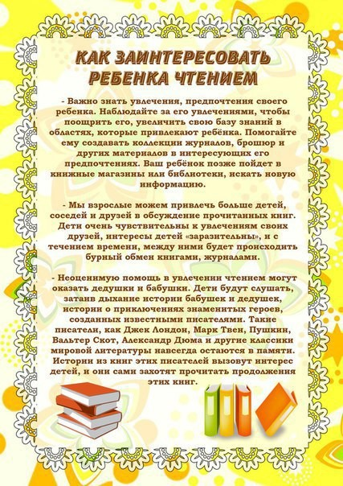](https://ok.ru/dk?cmd=PopLayerPhoto&st.layer.cmd=PopLayerPhotoOuter&st.layer.type=GROUP&st.layer.revNav=off&st.layer.limitedUi=false&st.layer.sphotoIds=857517654339;857517654083;857517653827;857517653571;857517653315;857517653059;857517668931&st.layer.showNav=on&st.layer.photoAlbumId=52181022212163&st.layer.epm=off&st.layer.photoId=857517653315&st.layer.opl=off&st.layer.navStartPhotoId=857517653315&st.layer.sbd=off&st.cmd=userMain&st._aid=GroupTopicLayer_openPhotoLayer)

[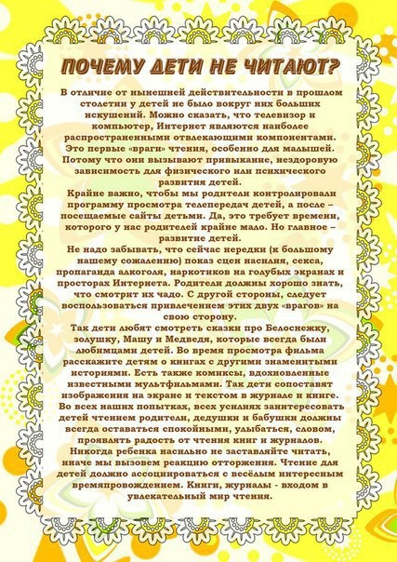](https://ok.ru/dk?cmd=PopLayerPhoto&st.layer.cmd=PopLayerPhotoOuter&st.layer.type=GROUP&st.layer.revNav=off&st.layer.limitedUi=false&st.layer.sphotoIds=857517654339;857517654083;857517653827;857517653571;857517653315;857517653059;857517668931&st.layer.showNav=on&st.layer.photoAlbumId=52181022212163&st.layer.epm=off&st.layer.photoId=857517653059&st.layer.opl=off&st.layer.navStartPhotoId=857517653059&st.layer.sbd=off&st.cmd=userMain&st._aid=GroupTopicLayer_openPhotoLayer)